MENU DRIVEN CALCULATOR
Using Object Oriented Programming in C++

Cornerstone project work submitted to Aditya University in partial fulfilment of the requirements for the award of the Degree of

B.Tech. degree
in
Computer Science & Engineering (2026-2027)

Y. Lochan | 25B11DS629
G. Ratan Teja | 25B11DS190
P. Vivek | 25B11DS409
K. Nagendra | 25B11DS245
SUBMITTED BY

UNDER THE GUIDANCE OF
K. K. V. Satyanarayana
Assistant Professor
Department of IT

Department of Computer Science & Engineering
Aditya University, Aditya Nagar, ADB Road,
Surampalem, Kakinada, District, Andhra Pradesh, India - 533437

DECLARATION

I hereby declare that the Cornerstone project work entitled “MENU DRIVEN CALCULATOR Using Object Oriented Programming in C++” is being submitted by me for the award of the B. Tech Degree in Computer Science and Engineering, Aditya University, Aditya Nagar, ADB Road, Surampalem is a record of original work carried out by us. We further declare that this project work has not been submitted, either in full or in part, for the award of any degree or diploma in this or any other institution. We also confirm that this work has been carried out with academic honesty and complies with the Institutional Academic Integrity and AI Usage Policy.

Submitted By
Y. Lochan | 25B11DS629
G. Ratan Teja | 25B11DS190
P. Vivek | 25B11DS409
K. Nagendra | 25B11DS245

Place: Surampalem
Date:

DEPARTMENT OF COMPUTER SCIENCE & ENGINEERING
ADITYA UNIVERSITY, ADITYA NAGAR,
SURAMPALEM.

This is to certify that the cornerstone project entitled “MENU DRIVEN CALCULATOR Using Object Oriented Programming in C++” is being submitted by Y. Lochan, G. Ratan Teja, P. Vivek, K. Nagendra in partial fulfilment for the award of B. Tech Degree from Aditya University, is a record of original work done by them under my supervision. The contents of this project, in full or in parts, have not been submitted to any other Institute or University for the award of any degree or diploma.

Project Guide
K. K. V. Satyanarayana
Assistant Professor
Department of IT
Aditya University

ACKNOWLEDGEMENT
It is with immense pleasure that we express our sincere gratitude to our Cornerstone Project Guide, GUIDE NAME, DESIGNATION, who has guided us throughout the project. Her valuable support, encouragement, and guidance have greatly contributed to the successful completion of this work.

We would like to thank our Deputy Heads of the Department, DY HOD-1, DESIGNATION, DY HOD-2, DESIGNATION AND DY HOD-3, DESIGNATION, Department of CSE, for their support and valuable suggestions.

Our deepest thanks to our Head of the Department, HOD NAME, DESIGNATION & HOD, for her inspiration and for providing all the necessary facilities and resources required for this project.

We also extend our sincere thanks to DR. M.V. RAJESH, ASSOCIATE DEAN, SCHOOL OF COMPUTING, for his encouragement and support during our project.

We would like to express our sincere gratitude to DR. G. SURESH, REGISTRAR; DR. A. RAMESH, PRO VICE-CHANCELLOR (ENGINEERING & SCIENCES); DR. S. RAMA SREE, PRO VICE-CHANCELLOR (ACADEMICS); DR. M.B. SRINIVAS, VICE-CHANCELLOR; AND DR. M. SREENIVASA REDDY, DEPUTY PRO CHANCELLOR AND MANAGEMENT, ADITYA UNIVERSITY, for providing excellent infrastructure and state-of-the-art laboratories.

Finally, we would like to thank the FACULTY MEMBERS, LAB TECHNICIANS, NON-TEACHING STAFF, AND OUR FRIENDS who have directly or indirectly supported us in completing this Cornerstone project successfully.

Name of the Students:
1. Y. Lochan
2. G. Ratan Teja
3. P. Vivek
4. K. Nagendra

ABSTRACT

The CAL-GEN: Menu Driven Calculator is a C++-based application developed to provide a simple, organized, and user-friendly platform for performing different types of mathematical and practical calculations. The project is designed using Object-Oriented Programming (OOP) concepts such as abstraction, encapsulation, inheritance, polymorphism, and function overloading.
The application follows a menu-driven approach, allowing users to select the required calculation from a centralized menu. The major modules include Arithmetic Calculations, BMI Calculation, Loan/EMI Calculation, and Academic Percentage and Grade Calculation. Each module is implemented as a separate derived class, while a common abstract base class provides shared functionality and demonstrates runtime polymorphism.
The system also incorporates input validation and error handling to prevent invalid inputs and common calculation errors such as division by zero. Function overloading is used to provide different ways of displaying calculation results, demonstrating compile-time polymorphism.
The main objective of CAL-GEN is to make mathematical calculations simpler, structured, and easier to understand while demonstrating the practical application of C++ OOP principles. The project combines multiple calculation utilities into a single application and provides a foundation that can be extended with additional calculators and features in the future.

ABBREVATIONS
The following table enumerates the technical acronyms, engineering terminologies and domain abbrevations utilized throughout this project documentation:
ABBREVATION | EXPANSION
OOP | Object Oriented Programming
C++17 | Programming language standard
CLI | Command Line Interface
BMI | Body Mass Index
EMI | Equated Monthly Installment
LIST OF FIGURES

Figure.No. | Figure Name | Pg.No.
Figure 1.1 | System Architecture of CAL-GEN
Figure 1.2 | Algorithm / Working Flow of CAL-GEN
Figure 1.3 | Flowchart of the Menu-Driven Calculator
Figure 2.1 | Class Hierarchy of CAL-GEN
Figure 2.2 | OOP Structure of CAL-GEN
Figure 2.3 | Runtime Polymorphism in CAL-GEN
Figure 2.4 | Main Function and Menu Flow
Figure 2.5 | Arithmetic Calculator Output
Figure 2.6 | BMI Calculator Output
Figure 2.7 | Loan and EMI Calculator Output
Figure 2.8 | Academic Calculator Output
LIST OF TABLES
Table.No. | Table Name | Pg.No
Table 1.1 | Project Modules and Their Functions
Table 1.2 | Hardware and Software Requirements
Table 2.1 | Classes Used in CAL-GEN
Table 2.2 | OOP Concepts Implemented
Table 2.3 | Arithmetic Operations Supported
Table 2.4 | BMI Classification
Table 2.5 | Academic Grade Classification
Table 2.6 | Input Validation and Error Handling

TABLE OF CONTENTS

CONTENTS | PAGE NO
Title Page | 1
Certificate | 2
Declaration | 3
Acknowledgement | 4
Abstract | 5
Abbreviations | 6
List of Figures | 7
List of Tables | 8
CHAPTER -1 Project Planning
1.1. Problem statement
1.2. Project Objective
1.3. Planned Modules
1.4. System Architecture (Algorithm & Flowchart)
CHAPTER -1 Project Implementation
2.1. OOP Concepts Used for implementation
2.2. Code
2.3. Output Screens
CHAPTER-3 Conclusion & Future Scope
3.1. Conclusion
3.2. Future Scope

CHAPTER – 1
PROJECT PLANNING
1.1 PROBLEM STATEMENT
People lose interest in mathematics because:
1. Complexity Overload
Calculations often appear complicated at first glance, causing learners to disengage before even attempting to understand the underlying logic.
2. Disconnected from Real-World Relevance
Students rarely see how mathematical concepts translate into real scientific, technological, or everyday applications, making mathematics feel abstract.
Proposed Solution
The CAL-GEN project addresses these issues by combining multiple practical calculations into a single menu-driven C++ application.
Instead of requiring separate programs for different calculations, the user can select the required calculator from a central menu.
The project also uses Object-Oriented Programming concepts to organize the application into separate and reusable calculator classes.
The system provides four main calculation modules:
- Arithmetic Calculator
- BMI Calculator
- Loan and EMI Calculator
- Academic Marks and Grade Calculator
This approach makes the program structured and allows different calculations to share common functionality through a base class
1.2 PROJECT OBJECTIVE
The main objective of CAL-GEN is to develop a menu-driven calculator using C++17 and Object-Oriented Programming concepts.
The specific objectives are:
- To develop a simple menu-driven calculator application.
- To combine multiple calculation utilities into one program.
- To implement Object-Oriented Programming concepts practically.
- To demonstrate abstraction using an abstract base class.
- To demonstrate encapsulation using private data members and public member functions.
- To demonstrate inheritance through derived calculator classes.
- To demonstrate compile-time polymorphism using function overloading.
- To demonstrate runtime polymorphism using virtual functions and overriding.
- To provide input validation and error handling.
- To prevent common calculation errors such as division by zero.
- To make the program modular and easier to extend.
1.3 PLANNED MODULES
CAL-GEN is divided into four major calculator modules.
1.3.1 Arithmetic Calculator
The Arithmetic Calculator performs basic mathematical operations.
The supported operations are:
- Addition
- Subtraction
- Multiplication
- Division
The user enters two numbers and an operator.
The program uses a switch statement to determine which arithmetic operation should be performed.
Division by zero is specifically checked and prevented.

1.3.2 BMI Calculator
The BMI Calculator calculates Body Mass Index using the user's weight and height.
The formula used is:
BMI = Weight / (Height × Height)
The weight is entered in kilograms and height is entered in metres.
The resulting BMI is classified into:
- Underweight
- Normal weight
- Overweight
- Obese
The program also validates that weight and height are positive values.

1.3.3 Loan and EMI Calculator
The Loan Calculator calculates:
- Monthly EMI
- Total interest payable
- Total amount to repay
The user provides:
- Loan principal amount
- Annual interest rate
- Loan tenure in months
The annual interest rate is converted into a monthly interest rate.
For a non-zero interest rate, the EMI is calculated using the standard EMI formula implemented with pow().
For a zero-interest loan, the program separately calculates:
EMI = Principal / Tenure
This avoids an invalid calculation involving division by zero.

1.3.4 Academic Marks and Grade Calculator
The Academic Calculator accepts:
- Marks obtained
- Total maximum marks
The percentage is calculated using:
Percentage = (Obtained Marks / Total Marks) × 100
The program then assigns a grade according to the percentage.
The implemented grading scheme is:
- 90% and above → A+
- 80% to below 90% → A
- 70% to below 80% → B
- 60% to below 70% → C
- 50% to below 60% → D
- Below 50% → F
The program also checks that obtained marks are not negative, total marks are positive, and obtained marks do not exceed total marks

TABLE 1.1 — PROJECT MODULES AND THEIR FUNCTIONS
Module | Function
Arithmetic Calculator | Performs addition, subtraction, multiplication and division
BMI Calculator | Calculates BMI and displays its category
Loan Calculator | Calculates EMI, total interest and total repayment
Academic Calculator | Calculates percentage and displays grade

TABLE 1.2 — HARDWARE AND SOFTWARE REQUIREMENTS
Hardware Requirements | Software Requirements
- Computer or laptop | - C++ compiler
- Keyboard | - C++17 standard
- Display | - Command Line Interface
- Sufficient memory to compile and execute a C++ program | - Development environment capable of compiling C++ source code

1.4 SYSTEM ARCHITECTURE
The CAL-GEN architecture is based on a common abstract base class called Calculator.
The base class contains common functionality shared by all calculator modules.
The derived classes are:

Each derived class inherits from Calculator and provides its own implementation of the calculate() function.
The architecture allows the main program to interact with different calculators through a common base-class interface.
This is the main mechanism through which runtime polymorphism is demonstrated

ALGORITHM: General Algorithm of CAL-GEN
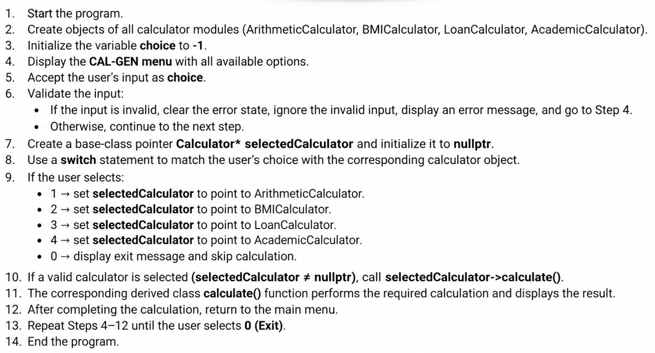
FLOWCHART DESCRIPTION
The flow of the application is:
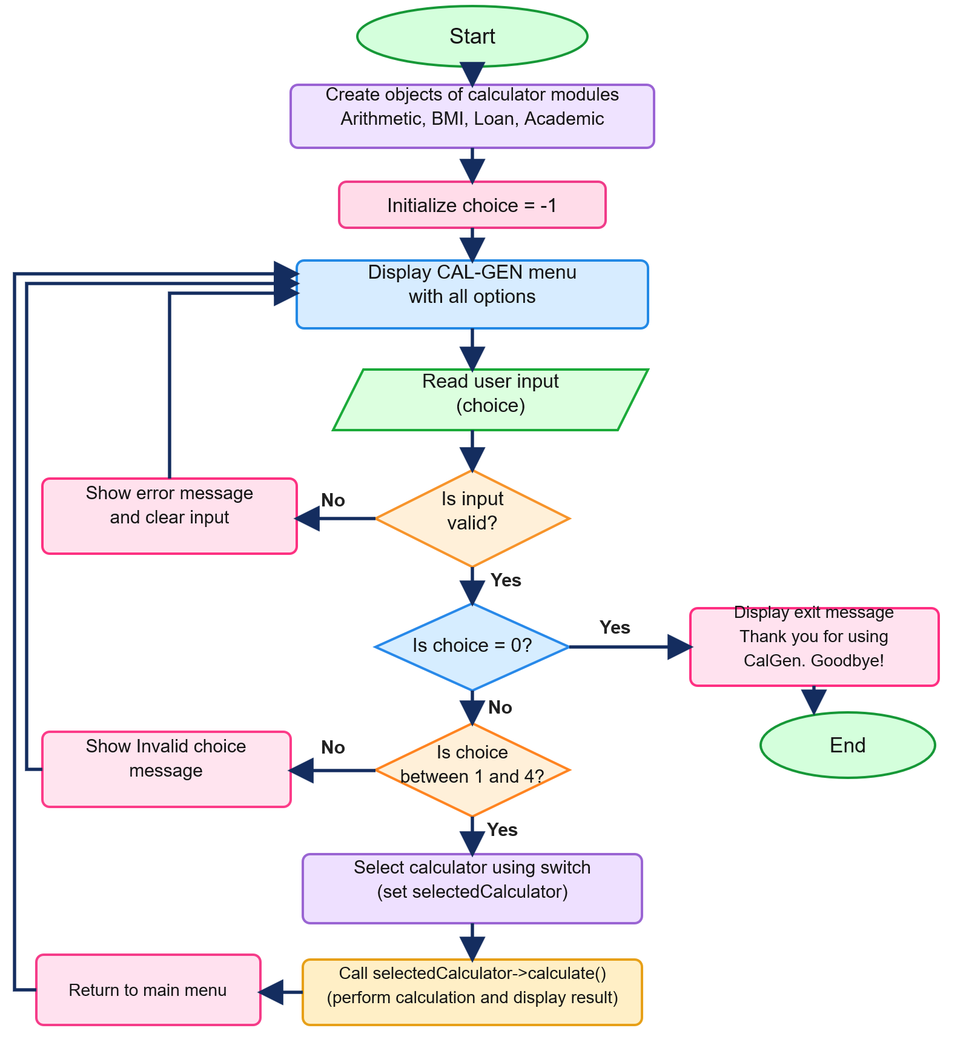
Fig. 1.4.1: Flowchart of the CAL-GEN menu-driven calculator

CHAPTER – 2
PROJECT IMPLEMENTATION
2.1 OOP CONCEPTS USED FOR IMPLEMENTATION
The CAL-GEN application is specifically designed to demonstrate Object-Oriented Programming concepts.
The major concepts used are:
- Abstraction
- Encapsulation
- Inheritance
- Polymorphism
- Function Overloading

2.1.1 ABSTRACTION
Abstraction is implemented through the Calculator base class.
The class contains the pure virtual function:
virtual void calculate() = 0;
Because calculate() is a pure virtual function, Calculator becomes an abstract class.
The base class defines what every calculator should provide without specifying how every individual calculation must be performed. Each derived class provides its own implementation. For example:
void calculate() override;
is implemented separately in:
- ArithmeticCalculator
- BMICalculator
- LoanCalculator
- AcademicCalculator
Thus, the calculation details are hidden behind a common interface.

2.1.2 ENCAPSULATION
Encapsulation is implemented using the private data member:
string name;
The name variable cannot be accessed directly outside the class.
Instead, controlled access is provided through:
string getName() const {
return name;
}
This ensures that the internal data of the class remains protected while still allowing required access through a public member function.

2.1.3 INHERITANCE
The calculator modules inherit from the common Calculator class.
For example: class ArithmeticCalculator : public Calculator
Similarly: class BMICalculator : public Calculator
class LoanCalculator : public Calculator
class AcademicCalculator : public Calculator
This allows all derived classes to reuse the common features of Calculator.
Inheritance reduces duplication and provides common structure for all calculator modules.

2.1.4 POLYMORPHISM
CAL-GEN demonstrates two forms of polymorphism.
Compile-Time Polymorphism
Function overloading is used in:
void showResult(const string& label, double value)
void showResult(double value)
Both functions have the same name but different parameter lists.
The appropriate function is selected based on the arguments supplied.

Runtime Polymorphism
Runtime polymorphism is implemented using:
virtual void calculate() = 0;
and overridden functions in the derived classes. In main():
Calculator* selectedCalculator = nullptr;
The pointer can refer to different derived calculator objects.
For example: case 1: selectedCalculator = &arithmetic; break;
case 2: selectedCalculator = &bmi; break;
case 3: selectedCalculator = &loan; break;
case 4: selectedCalculator = &academic; break;
The call: selectedCalculator->calculate();
then invokes the correct derived-class implementation. This is runtime polymorphism.

TABLE 2.1 — CLASSES USED IN CAL-GEN
Class | Purpose
Calculator | Abstract base class containing common functionality
ArithmeticCalculator | Performs arithmetic operations
BMICalculator | Calculates BMI
LoanCalculator | Calculates EMI and loan repayment details
AcademicCalculator | Calculates percentage and grade

TABLE 2.2 — OOP CONCEPTS IMPLEMENTED
OOP Concept | Implementation
Abstraction | Pure virtual calculate() function
Encapsulation | Private name data member and getName()
Inheritance | Derived calculator classes inherit from Calculator
Compile-Time Polymorphism | Overloaded showResult()
Runtime Polymorphism | Virtual calculate() and base-class pointer

2.2 CODE
2.2.1 Header Files
#include <iostream> // used for input and output
#include <string> // provides the string data type
#include <iomanip> // used for output formatting
#include <cmath> // provides mathematical functions
using namespace std;

2.2.2 BASE CLASS — CALCULATOR
class Calculator {
private:
string name;
public:
Calculator(const string& calcName) : name(calcName) {}
virtual ~Calculator() = default;
string getName() const {
return name;
}
virtual void calculate() = 0;
void showResult(const string& label, double value) {
cout << "[Result] " << label << ": "
<< fixed << setprecision(2)
<< value << "\n";
}
void showResult(double value) {
cout << "[Result]: "
<< fixed << setprecision(2)
<< value << "\n";
}
};
Explanation
The Calculator class is the common base class for all calculator modules. The private member: string name; stores the calculator name.
The constructor: Calculator(const string& calcName) : name(calcName) {} initializes the name. The virtual destructor: virtual ~Calculator() = default; allows the class to be safely used as a polymorphic base class. The getter: string getName() const provides controlled access to the private name. The pure virtual function: virtual void calculate() = 0; makes the class abstract. The two showResult() functions demonstrate function overloading.
2.2.3 ARITHMETIC CALCULATOR
class ArithmeticCalculator : public Calculator {
public:
ArithmeticCalculator()
: Calculator("Basic Arithmetic Calculator") {}
void calculate() override {
double a, b;
char op;
cout << "\n--- " << getName() << " ---\n";
cout << "Enter first number: ";
cin >> a;
cout << "Enter operator (+, -, *, /): ";
cin >> op;
cout << "Enter second number: ";
cin >> b;
if (cin.fail()) {
cin.clear();
cin.ignore(10000, '\n');
cout << "Error: Invalid numeric input.\n";
return;
}
switch (op) {
case '+': showResult("Sum", a + b); break;
case '-': showResult("Difference", a - b); break;

case '*': showResult("Product", a * b); break;
case '/':
if (b == 0) {
cout << "Error: Cannot divide by zero.\n";
} else {
showResult("Quotient", a / b);
}
break;
default:
cout << "Error: Unsupported operator '" << op << "'.\n";
}
}
};
Working
The user enters two numbers and an operator. The switch statement determines the requested operation. For division, the program checks: if (b == 0) before performing the calculation. This prevents division by zero.
2.2.4 BMI CALCULATOR
// 2. BMI Calculator (Health & Fitness)
class BMICalculator : public Calculator {
public:
BMICalculator() : Calculator("BMI Calculator") {}

// Runtime Polymorphism: overriding the pure virtual function
void calculate() override {
double weight, height;
cout << "\n--- " << getName() << " ---\n";
cout << "Enter weight in kg: ";
cin >> weight;
cout << "Enter height in meters: ";
cin >> height;
if (cin.fail() || weight <= 0 || height <= 0) {
cin.clear();
cin.ignore(10000, '\n');
cout << "Error: Weight and height must be positive numbers.\n";
return;
}
double bmi = weight / (height * height);
showResult("BMI Score", bmi);
if (bmi < 18.5) cout << "Category: Underweight\n";
else if (bmi < 24.9) cout << "Category: Normal weight\n";
else if (bmi < 29.9) cout << "Category: Overweight\n";
else cout << "Category: Obese\n";
}
};

2.2.5 LOAN EMI & INTEREST CALCULATOR
// 3. Loan & Interest Calculator (Finance / Loan EMI)
class LoanCalculator : public Calculator {
public:
LoanCalculator() : Calculator("Loan EMI & Interest Calculator") {}

// Runtime Polymorphism: overriding the pure virtual function
void calculate() override {
double principal, annualRate;
int tenureMonths;
cout << "\n--- " << getName() << " ---\n";
cout << "Enter loan principal amount: ";
cin >> principal;
cout << "Enter annual interest rate (%): ";
cin >> annualRate;
cout << "Enter loan duration (tenure in months): ";
cin >> tenureMonths;
if (cin.fail() || principal <= 0 || annualRate < 0 || tenureMonths <= 0) {
cin.clear();
cin.ignore(10000, '\n');
cout << "Error: Invalid inputs. Principal and months must be positive.\n";
return;
}
double emi;
double monthlyRate = annualRate / (12.0 * 100.0);
if (monthlyRate == 0) {
emi = principal / tenureMonths;
} else {
double factor = pow(1.0 + monthlyRate, tenureMonths);
emi = (principal * monthlyRate * factor) / (factor - 1.0);
}
double totalPayment = emi * tenureMonths;
double totalInterest = totalPayment - principal;
showResult("Monthly EMI", emi);
showResult("Total Interest Payable", totalInterest);
showResult("Total Amount to Repay", totalPayment);
}
};

2.2.6 ACADEMIC CALCULATOR
// 4. Academic Calculator (Marks, Percentage & Grade)
class AcademicCalculator : public Calculator {
public:
AcademicCalculator() : Calculator("Academic Marks & Grade Calculator") {}

// Runtime Polymorphism: overriding the pure virtual function
void calculate() override {
double obtained, total;
cout << "\n--- " << getName() << " ---\n";
cout << "Enter marks obtained: ";
cin >> obtained;
cout << "Enter total maximum marks: ";
cin >> total;
if (cin.fail() || obtained < 0 || total <= 0 || obtained > total) {
cin.clear();
cin.ignore(10000, '\n');
cout << "Error: Obtained marks must be between 0 and total marks.\n";
return;
}
double percentage = (obtained / total) * 100.0;
showResult("Score Percentage", percentage);
cout << "Grade: ";
if (percentage >= 90.0) cout << "A+ (Outstanding)\n";
else if (percentage >= 80.0) cout << "A (Excellent)\n";
else if (percentage >= 70.0) cout << "B (Good)\n";
else if (percentage >= 60.0) cout << "C (Satisfactory)\n";
else if (percentage >= 50.0) cout << "D (Pass)\n";
else cout << "F (Fail)\n";
}
};

2.2.7 MAIN FUNCTION
// Core OOP concept 4: Runtime Polymorphism
int main() {
// Instantiate concrete derived objects
ArithmeticCalculator arithmetic;
BMICalculator bmi;
LoanCalculator loan;
AcademicCalculator academic;
int choice = -1;
do {
cout << "\n========================================\n";
cout << " CAL-GEN CONSOLE \n";
cout << "========================================\n";
cout << "1. " << arithmetic.getName() << "\n";
cout << "2. " << bmi.getName() << "\n";
cout << "3. " << loan.getName() << "\n";
cout << "4. " << academic.getName() << "\n";
cout << "0. Exit\n";
cout << "----------------------------------------\n";
cout << "Choose an option: ";
cin >> choice;
if (cin.fail()) {
cin.clear();
cin.ignore(10000, '\n');
cout << "Invalid choice. Please enter a valid number.\n";
continue;
}
// Base-class pointer selects different child objects at runtime
Calculator* selectedCalculator = nullptr;
switch (choice) {
case 1: selectedCalculator = &arithmetic; break;
case 2: selectedCalculator = &bmi; break;
case 3: selectedCalculator = &loan; break;
case 4: selectedCalculator = &academic; break;
case 0:
cout << "Thank you for using CalGen. Goodbye!\n";
break;
default:
cout << "Invalid choice. Please select 0, 1, 2, 3, or 4.\n";
}
// Runtime polymorphism: dispatch to selected calculator
if (selectedCalculator != nullptr) {
selectedCalculator->calculate();
}
} while (choice != 0);
return 0;
}

CHAPTER – 3
CONCLUSION AND FUTURE SCOPE
3.1 Conclusion
The CAL-GEN: Menu Driven Calculator was successfully developed as a C++ application for performing different mathematical and practical calculations through a simple menu-driven interface. It combines multiple calculation modules into one organized application.
The project demonstrates key Object Oriented Programming (OOP) concepts, including abstraction, encapsulation, inheritance, polymorphism, and function overloading. The abstract Calculator class provides common functionality, while derived classes implement specific calculations.
The application includes Arithmetic, BMI, Loan/EMI, and Academic calculators. Each module performs its required calculation with appropriate input validation and error handling. Common errors such as invalid inputs and division by zero are also handled.
Function overloading demonstrates compile-time polymorphism, while virtual functions and overriding demonstrate runtime polymorphism. The common base class makes the program modular and easier to extend.
Overall, CAL-GEN demonstrates how C++ OOP principles can be applied to develop a practical and structured multi-purpose calculator.

3.2 Future Scope
CAL-GEN can be further extended with additional features and calculation modules:
- Scientific Calculator – Trigonometric, logarithmic, exponential, and other scientific operations.
- Unit Conversion – Conversion of length, weight, temperature, currency, and other units.
- Financial Calculations – Savings, investment, interest, and other financial calculations.
- Improved User Interface – A more interactive graphical interface while retaining the existing calculation logic.
- Enhanced Input Validation – More comprehensive validation for different inputs and edge cases.
- Additional Practical Calculators – Calculators for areas, volumes, dates, time, and other everyday applications.
- Modular Expansion – New calculator classes can be added easily using the existing inheritance and polymorphism-based design.
Thus, CAL-GEN provides a foundation that can be expanded into a more comprehensive multi-purpose calculation system.

